

# ICE2- Constraints

**Assignment #4:**

**Student Name: The Cuong, Bui**

**Student ID: C0770339**

**Date: Nov 18th, 2019**

The following constraints (business rules) have been determined for some business:

Create Database EMPLOYEE;

# librarian

|  |  |  |  |  |
| --- | --- | --- | --- | --- |
| **Attribute** | **Data Type** | **Length** | **NULL Capable** | **Constraints** |
| Librarian_id (PK) | Numeric | 7,0 | N |  |
| fname | Character | 20 | N |  |
| initial | Character | 20 | N |  |
| lname | Character | 20 | Y |  |
| Librarian_emai | Character | 30 | Y |  |

create table librarian

( librarian_id numeric(7,0) NOT null,

librarian_fname VARCHAR(20) not null,

librarian_lname VARCHAR(20) not null,

librarian_email VARCHAR(30) not null,

librarian_phone VARCHAR(30) not null,

CONSTRAINT librarian_id_pk

primary key(librarian_id));

# college_resource_role

|  |  |  |  |  |
| --- | --- | --- | --- | --- |
| **Attribute** | **Data Type** | **Length** | **NULL Capable** | **Constraints** |
| role_id (PK) | Integer | 2,0 | N |  |
| resource_role_descriptionptio | Character | 20 | N |  |

# library_card

|  |  |  |  |  |
| --- | --- | --- | --- | --- |
| **Attribute** | **Data Type** | **Length** | **NULL Capable** | **Constraints** |
| Card_type_id (PK) | Numeric | 7,0 | N |  |
| card_type (FK) | Character | 20 | N |  |
| No_due_days | Integer | 2,0 | N | If Student, default no_due_days is 7, instructor, default no_due_days is 90,  Others, default no_due_days is 90, |
| penalty_per_day | Double | 2,0 | N | If Student, default penalty_per_day is $5, instructor, default penalty_per_day is $2,  Others, default penalty_per_day is $7, |

create table library_card_type

( card_type_id numeric(7,0) NOT null,

Card_role VARCHAR(20) not null,

No_due_days Integer not null,

Penalty_per_day Double(2,0) not null,

CONSTRAINT library_card_type_id_pk

primary key(card_type_id));

locations data:

|  |  |  |
| --- | --- | --- |
| **location_id** | **city** | **store_manager** |
| 11 | Sarnia | null |
| 22 | London | null |
| 33 | Toronto | null |

select * from locations;

insert into locations(Location_ID, City) VALUES (11, 'Sarnia');

insert into locations(Location_ID, City) VALUES (22, 'London');

insert into locations(Location_ID, City) VALUES (33, 'Toronto');

select * from locations;

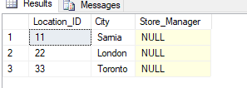

# locations_departments

|  |  |  |  |  |
| --- | --- | --- | --- | --- |
| **Attribute** | **Data Type** | **Length** | **NULL Capable** | **Constraints** |
| location ID (PK) | Numeric | 2,0 | N | Must be a valid location |
| department_id (PK) | Numeric | 4,0 | N | Must be a valid department |
| department_manager | Numeric | 5,0 | Y |  |

create table locations_department(

location_ID Numeric(2,0) not null, department_id Numeric(4,0) not null, deparment_Manager Numeric(5,0),

Constraint employee_location_department_id_pk PRIMARY KEY(department_id, location_ID),

Constraint employee_location_department_location_id_fk FOREIGN KEY(location_ID) REFERENCES locations(Location_ID),

Constraint employee_location_department_department_id_fk FOREIGN KEY(department_id) REFERENCES departments(department_id)

);

select * from locations_department;

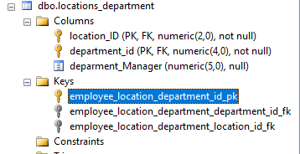

**departments**

|  |  |  |  |
| --- | --- | --- | --- |
| **Attribute** | **Data Type** | **Length** | **NULL Capable** |
| Department ID (PK) | Numeric | 4,0 | N |
| Department name | Character | 50 | N |

create table departments(

department_id Numeric(4,0) not null, department_name varchar(50) not null

constraint employee_department_id_pk PRIMARY KEY(department_id));

select * from departments;

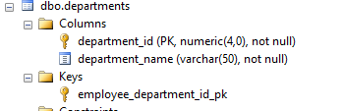

departments data:

|  |  |
| --- | --- |
| **department_id** | **department_name** |
| 1001 | IT |
| 1002 | Administration |
| 1003 | Men's Clothing |
| 1004 | Women's Clothing |
| 1005 | Kids |
| 1006 | Toys |

insert into departments VALUES (1001, 'IT');

insert into departments VALUES (1002, 'Administration');

insert into departments VALUES (1003, 'Men ''s Clothing');

insert into departments VALUES (1004, 'Women''s Clothing');

insert into departments VALUES (1005, 'Kids');

insert into departments VALUES (1006, 'Toys');

select * from departments;

# 

# Employees

|  |  |  |  |  |
| --- | --- | --- | --- | --- |
| **Attribute** | **Data Type** | **Length** | **NULL**  **Capable** | **Constraints** |
| Employee ID (PK) | Numeric | 5,0 | N | * Unique identifier |
| First name | Character | 15 | N |  |
| Middle Initial | Character | 1 | Y |  |
| Last Name | Character | 15 | N |  |
| Social Security No | Numeric | 9,0 | N | * Unique * Between 0 and 999999999 |
| Birth Date | Date | 10 | N | * Greater than 1970-01-01 |
| Sex | Character | 1 | N | * Must be 'F' or 'M' |
| Pension Contributor | Boolean | 1 | N | * 1=Yes; 0=No |
| Hire Date | Date | 10 | N | * If unknown, use current date * Must be greater than birth date |
| Store Location | Numeric | 2,0 | N |  |
| Work Department | Numeric | 4,0 | Y | * If unknown, use '1000' |
| Job Class | Character | 1 | Y | * If unknown, use 'T' * Must be 'T', 'J', 'C', or 'M' |
| Job level | Numeric | 2,0 | N | * Greater than 0 and less than 10 |
| Coach ID | Numeric | 5,0 | Y |  |
| Salary | Numeric | 9,2 | N | * Must be less than 92000.00 * Must be greater than commission |
| Bonus | Numeric | 7,2 | Y | * Must have commission or bonus |
| Commission | Numeric | 7,2 | Y | * Must have commission or bonus |

create table employees(

Employee_ID Numeric(5,0) not null,

Constraint employees_employee_id_pk PRIMARY KEY(Employee_ID),

Constraint employees_employee_id_uq UNIQUE(Employee_ID),

First_Name varchar(15) not null,

Middle_Initital char(1),

Last_Name varchar(15) not null,

Social_Security_Number Numeric(9,0) not null,

Constraint employees_soc_sec_num_uq UNIQUE(Social_Security_Number),

Constraint employees_soc_sec_num_ck CHECK( Social_Security_Number >= 0 AND Social_Security_Number <=999999999),

Birth_Date Date not null,

Constraint employees_birth_date_ck CHECK( Birth_Date >= '1970-01-01'),

Sex char(1) not null,

Constraint employees_sex_ck CHECK( Sex = 'F' OR sex = 'M'),

Pension_Contributor bit not null,

Constraint employees_pension_contributor_ck CHECK( Pension_Contributor = 1 OR Pension_Contributor = 0),

Hire_Date Date,

Constraint employees_hire_date_ck CHECK( Hire_Date > Birth_Date),

Store_Location numeric(2,0) not null,

Constraint employees_store_location_fk FOREIGN KEY(Store_Location) REFERENCES locations(Location_ID),

Work_Department numeric(4,0) DEFAULT 1000,

Constraint employees_work_department_fk FOREIGN KEY(Work_Department) REFERENCES departments(department_id),

Job_Class Char(1) ,

Constraint employees_job_class_ck CHECK( Job_Class in ('T', 'J', 'C', 'M')),

Job_Level numeric(2,0) not null,

Constraint employees_job_level_ck CHECK( Job_Level > 0 and Job_Level < 10),

Coach_ID numeric(5,0) ,

Salary numeric(9,2) not null,

Bonus numeric(7,2) ,

Commission numeric(7,2) ,

Constraint employees_commission_bonus_ck CHECK( commission > 0 or bonus >0),

Constraint employees_salary_ck CHECK( salary < 92000.00 and ( salary > commission or salary > bonus))

);

Alter table employees

ADD Constraint df_employees_hire_date default GETDATE() FOR Hire_Date;

Alter table employees

ADD Constraint df_employees_job_class default 'T' FOR Job_Class;

Alter table employees

Add Constraint df_employees_work_department default 1000 for Work_Department;

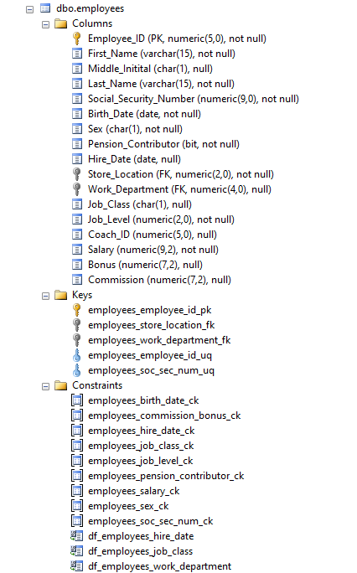

1. Create the database to include all tables, fields and constraints
2. Constraint Testing – Test at least six different constraints by listing each constraint and providing a test to validate that each constraint is working as follows:
   1. Include an INSERT statement to "force" a constraint error. For example, modify the employee_id so that it is the same as the employee_id in the previous row. This will force a primary key error when the INSERT statement is run
   2. Run the INSERT statement and verify that the error occurred
   3. Take a screen shot of the error and insert into the constraint testing document
   4. Move to the next constraint and perform a constraint test

/* Valid data against constraint*/

insert into employees VALUES (10000, 'Cuong', 'T', 'Bui', 100000000, '1983-07-22', 'M', 1, '2019-08-26', 11, 1005, 'J', 5, 1234, 60000.00, 0, 5000);

select * from employees



**Test #1: Test constraint Unique of Primary Key Employee_ID**

insert into employees VALUES (10000, 'Cuong1', 'T', 'Bui1', 100000001, '1991-07-21', 'M', 1, '2006-04-30', 22, 1005, 'M', 8, 1230, 560000.00, 1000, 5000);

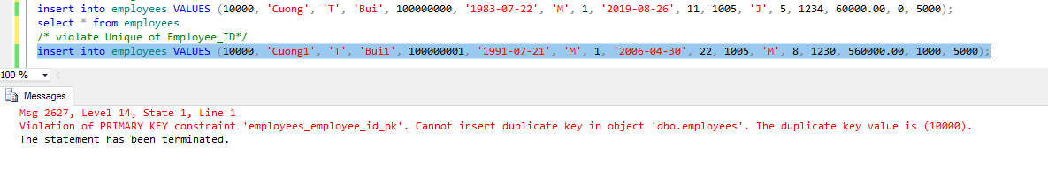

**Test #2: test range constraint of Social Security Number**

insert into employees VALUES (10009, 'Cuong1', 'T', 'Bui1', -1, '1991-07-21', 'M', 1, '2006-04-30', 22, 1005, 'M', 8, 1230, 560000.00, 1000, 5000);

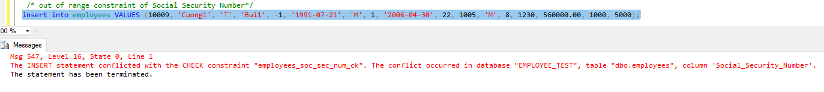

**Test #3: test invalid Sex constraint**

insert into employees VALUES (10010, 'Cuong10', 'T', 'Bui10', 100000010, '1999-07-21', 'S', 1, '2016-05-29', 33, 1003, 'M', 7, 1231, 660000.00, 0, 5000);



**Test #4: test hire_date constraint**

/* hire_date constraint*/

insert into employees VALUES (10011, 'Cuong11', 'T', 'Bui11', 100000011, '1989-06-21', 'F', 0, '1969-04-19', 33, 1004, 'M', 7, 1231, 660000.00, 0, 5000);



**Test #5: test default hire_date and Job class constraint**

insert into employees(Employee_ID, First_Name, Middle_Initital, Last_Name, Social_Security_Number, Birth_Date, Sex, Pension_Contributor, Store_Location, Work_Department, Job_Level, Coach_ID, Salary, Bonus, Commission)

**Test #6: Test constraint default of Work Department**

insert into employees(Employee_ID, First_Name, Middle_Initital, Last_Name, Social_Security_Number, Birth_Date, Sex, Pension_Contributor, Store_Location, Job_Level, Coach_ID, Salary, Bonus, Commission)

VALUES (10002, 'Cuong01', 'T', 'Bui01', 100000002, '1989-06-21', 'F', 0, 33, 7, 1231, 66000.00, 0, 5000);



This error is due to that the table employees assign default department 1000 while there is no department ‘1000’ constraint in Foreign key table.

There are 2 ways to fix this.

1. Add department 1000 to the Department table.

insert into departments VALUES (1000, 'Others');

1. Modify default constraint of work department to valid value of Department table.

ALTER TABLE employees

ADD CONSTRAINT df_employees_work_department

DEFAULT 1001 FOR Work_Department;

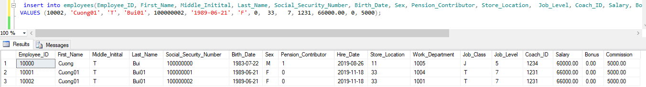

**Good Luck**